**Project Design Phase**

**Solution Architecture**

|  |  |
| --- | --- |
| Date | 24 June 2025 |
| Team ID | LTVIP2025TMID20428 |
| Project Name | FlightFinder |
| Mentor Name | Dr Shaik Salma Begam |
| Maximum Marks | 4 Marks |

**Solution Architecture:**

Solution architecture is a complex process – with many sub-processes – that bridges the gap between business problems and technology solutions. Its goals are to:

* Find the best tech solution to solve existing business problems.
* Describe the structure, characteristics, behavior, and other aspects of the software to project stakeholders.
* Define features, development phases, and solution requirements.
* Provide specifications according to which the solution is defined, managed, and delivered.

**Example - Solution Architecture Diagram:**

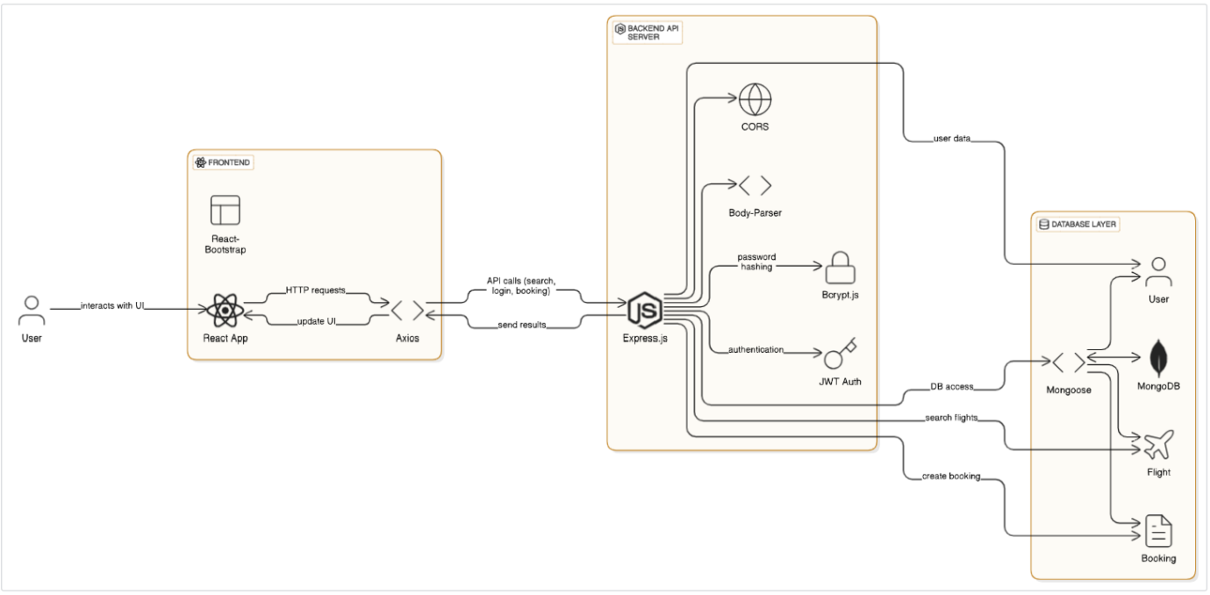

*Figure 1: Architecture and data flow of the sample application*

**Reference: <https://aws.amazon.com/blogs/industries/voice-applications-in-clinical-research-powered-by-ai-on-aws-part-1-architecture-and-design-considerations/>**

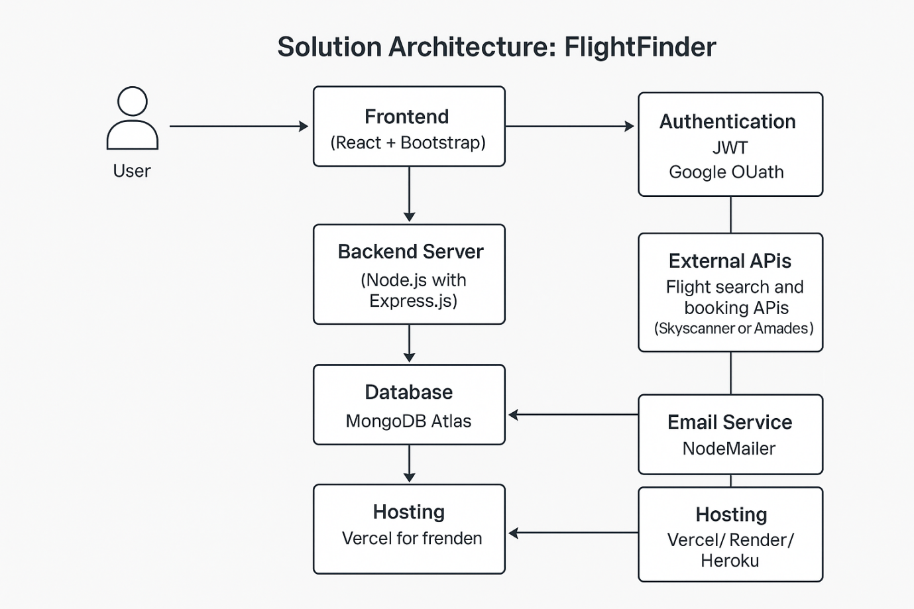

**Key Goals of Our Solution Architecture:**

1. ✅ Provide a secure, user-friendly platform for booking and tracking flights.
2. ✅ Support features like authentication, personalized suggestions, booking history, and real-time updates.
3. ✅ Ensure smooth integration with external APIs (e.g., flight search APIs).
4. ✅ Allow the system to scale efficiently as the number of users grows.

**Architecture Components:**

| **Layer** | **Technology** | **Purpose** |
| --- | --- | --- |
| Frontend | React.js + Bootstrap | UI for user registration, login, search, booking, and tracking |
| Backend | Node.js with Express.js | RESTful API services, authentication, session management, data processing |
| Database | MongoDB Atlas | Stores user info, flight data, booking history |
| Authentication | JWT (JSON Web Token), Google OAuth | Secure login via email/password and third-party providers |
| API Layer | Third-party Flight APIs (e.g., Amadeus, Skyscanner) | Fetches real-time flight availability, pricing, and booking options |
| Email Service | NodeMailer / SMTP | Sends registration and booking confirmation emails |
| Hosting/Deployment | Vercel (Frontend) + Render/Heroku (Backend) | Manages continuous deployment and uptim |